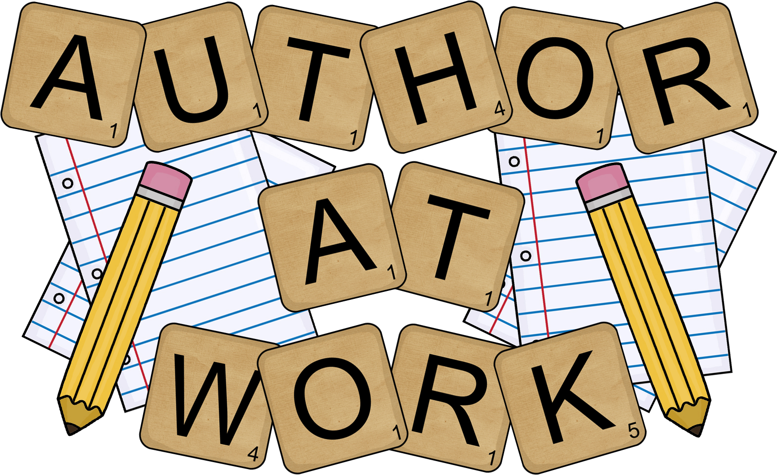
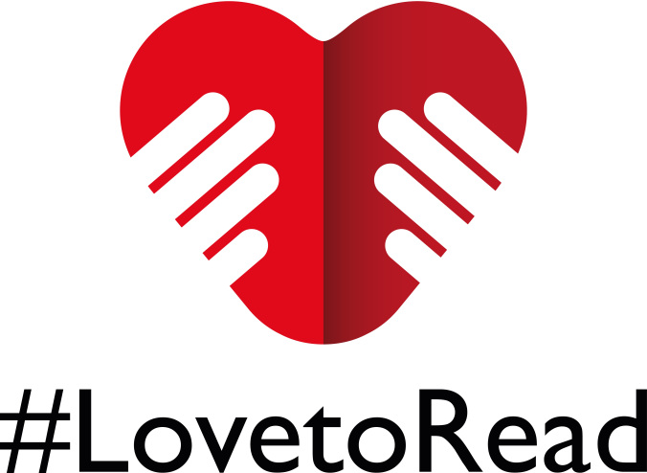
Foundations in English 1-2
Mrs. Gomez
North Valleys High School 2018-2019

Phone: 677-5499 x32643 Email: dgomez@washoeschools.net
Room: #212 Website: www.washoeschools.net/dgomez

Course Content
This freshmen level course provides students with specially designed instruction in language arts. Upon completion of this course, students will be prepared to participate in both ELA and End of Course Exams (graduation requirements). This class will focus on reading skills, writing skills, presentation skills, and test taking strategies. Writing instruction will focus on development of a thesis/claim, organization, using proper textual evidence, and providing analysis/explanation that supports the thesis/claim. The focus the course will be on developing language skills such as ideas, organization, conventions, and voice. Writing and reading assignments will incorporate higher level thinking skills such as synthesis and analysis. Fiction and nonfiction texts will focus on a variety of authors and backgrounds. There will be a research component in the course. Students will be taught using a variety of teaching techniques from direct instruction to group work.
Readings
We will be reading two to four books as a class. Class novels will be checked out to students and they will be assigned nightly reading from the novel. This is in addition to Panther Odyssey reading. Below you will see a list of all possible readings. Required readings may include the following: The chocolate War, Cold Sassy Tree, The Hobbit, Never Cried Wolf, Of Mice and Men, Raisin in the Sun, To Kill a Mockingbird, Warriors Don’t Cry, Much Ado About Nothing, The Haunting of Hill House, The House on Mango Street, the Odyssey, Oedipus The King, Romeo & Juliet, Well-Schooled in Murder, the Help, Elements of Literature (Third Course), newspapers, magazines, websites, and handouts.
Course Requirements
Materials
- Planner/Student ID (both provided by NVHS) – need to leave the classroom for any reason
- 1” binder with dividers (provided by teacher)
- Pen/pencils, paper (supplied by student)
- Silent Reading book (checked out from the library)
Grading & Assessments
- Independent Reading 15%
- In Class Reading 15%
- Writing 30%
*Daily/Weekly grades based on effort, participation, work completed, projects and/or tests.
Grades will not be rounded up for a higher grade.
- Conventions 10%
- Listening/Speaking 10%
- Final 20%
Late Assignments
Late work will be accepted for partial credit before the end of each quarter. No late work accepted from previous quarter.

Class Rules and Expectations

You are expected to come to class and be prepared to learn. You are to demonstrate respect for yourself and others at all times, which means there should be no insults, gossip, emotional or physical abuse, etc. Any offense will receive immediate consequences. Please review the North Valleys High School Student Handbook found in your Student Planner.
- Be Ready
- Be on time and prepared (paper, pencil, Silent Reading book, Planner, ID)
- Be Responsible
- Complete your own work
- Take responsibility for your actions.
- Be Respectful
- Use appropriate language at all times
- Keep cell phones & electronic devices turned off) , hats, headphones, etc. out of sight
- Water only (no gum, food, or drinks)
- Follow school-wide rules (SEE SCHOOL-WIDE EXPECTATIONS MATRIX in Student Planner)
Technology
- Students are not allowed to use cell phones in class, and my class is not charging station.
- All electronic devices must be silenced and put away in backpacks. Backpacks will be stored at the back of the class during entire class period.
- If I see or hear your electronic device (earbuds, cords, chargers, phones, etc.) – it will be sent to the discipline office. (This is your first & final warning).
- If there is an emergency and your parents need to get in touch with you, please have them call the main line at (775) 677-5499. Your parents are able to contact you, so that you do not get in trouble for breaking the technology rule.
- At times an electronic device is an appropriate learning tool. However, this is at the teacher’s discretion.
Behavior – NVHS school wide Progressive Discipline Plan
The following progressive discipline plan will be taken up for those students who do not follow the rules:
Level 1: Verbal Warning with redirection and documentation
Level 2: Verbal Warning with Detention, and phone call home with documentation
Level 3: Referral to SSO (Student Support Office) with consequence and phone call home with documentation
Level 4: SSO Parent Conference with referral to SSO, phone call home by teacher and discipline office, documentation, and parent meeting arranged.
Level 5: Behavior Plan or IEP Intervention Meeting with all teachers. Student will be referred to SSO with documentation and phone call home by teacher and discipline office. Meeting will need to be held before student can return to class.
*If the behavior is extremely offensive or disruptive, a referral to SSO may be made for the first offense.*

Attendance
Seven (7) unverified absences in any one class will result in automatic failure in that class, per the WCSD Attendance Policy. It is the student’s responsibility to consult the instructor immediately after returning from an absence to discuss missed instruction and assignments.

Tardy Policy
You will be considered tardy if you are not in your seat and ready to learn when the bell rings. Tardies will result in lowering of your citizenship grade. Please see your planner for detailed explanation of NVHS tardy policy and consequences.

Dear Parents and Guardians:

I am excited and thrilled to have your student in my English class this year! I will constantly be working so that your student can be successful. My goal is to create a community of learners who can work together in a safe and respectful way. I hope to challenge the way my student’s view reading and writing, so that they can develop higher levels of thinking skills along with effective ways to communicate. They will carry the skills learned this year throughout the rest of their education.

Students will be asked to read a range of literature; including poetry, novels, essays and short stories. In addition to reading, students will compose and complete many types of writing; this will be done in class. Students may not like or agree with the reading and writing we will be working on this year. To have a successful year I expect students to actively participate in a way that is respectful to all other students, so as to not interrupt the learning process for others.

Following this letter is a signature page/permission slip. I am asking that you and your student both sign, fill out, and return this last page; this shows that you both have read and understood what is being asked of your student for the following year. This will go in as your student’s first grade.

I want each and every one of my students to be successful this year, and I am more than willing to help in any way I can. If you have any questions or comments you would like to share, please feel free to contact me at dgomez@washoeschools.net.

Sincerely,

Denise Gomez, M.Ed.

Mrs. Gomez’s
Foundations in English 1-2
2018-2019

Please read, sign, detach, and return this form to Mrs. Gomez. Parents, if you have any questions, concerns, or comments, please make a note on the bottom or back of this page before it is returned to me. Thank you.

I, (print student name)

______________________________________________________
understand and agree to follow the rules and expectations of this class.

Student Signature Date

____________________________________ ________________________

Parent/Guardian Signature Date

____________________________________ ________________________

Parent Contact Information

Parent/Guardian Names (please print) ________________________________________

Home phone ________________________ Work Phone _________________________

Cell Phone _________________________ E-mail ______________________________

Best way to reach you during school hours _____________________________________

Anything else you would like me to know?

________________________________________________________________________

Movie Permission

I give my student permission to watch G, PG, and PG-13 movies that directly relate to the English curriculum.

Parent/Guardian Signature _________________________ Date ___________________

